Hiram Elementary School families,
If needed, these resources are available for your use. Scan the QR Codes or use the website links to access these helpful resources.

Hiram Elementary School
200 Seaboard Ave.
Hiram, GA 30141
770-443-3392


Computer Basics  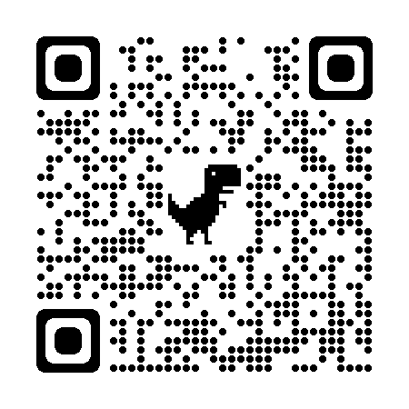  https://tinyurl.com/237zurdk | Copyright Piracy  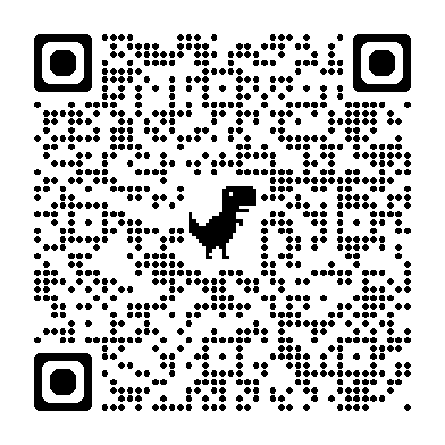  https://tinyurl.com/5838sznn | K-5 Family Tips:  Online Safety & Privacy  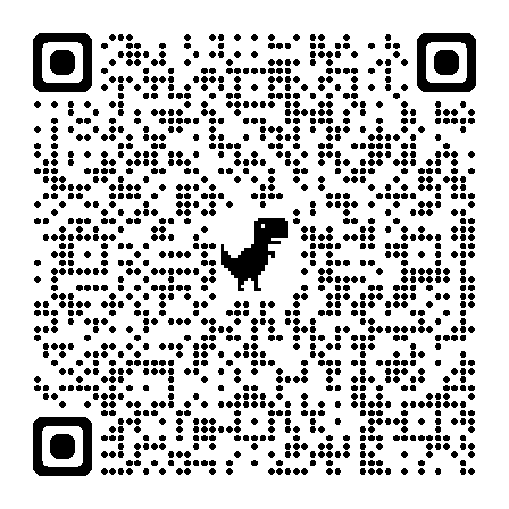  https://tinyurl.com/2p8js5wu
GED Classes  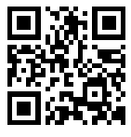  http://tinyurl.com/59dcp6ha | English as a Second Language Classes  (English and Spanish Information)  http://tinyurl.com/59dcp6ha
Please visit our Parent Resource Center located in the school media center. Parents can check out items to use with their student at home.
If you have any questions about these resources please contact Jill Brogdon, Hiram Title I ILC, at (770) 443-3392 ext. 14096 or jbrogdon@paulding.k12.ga.us.

